***Viburnum suspensum* Growth in a Nursery Using Plastic and Fabric Containers**

Tom Yeager1* and Ted Gardner2

1*University of Florida Institute of Food and Agricultural Sciences Extension, Department of Environmental Horticulture, Gainesville, FL*

2*Hibernia Nursery, Webster, FL*

**Additional index words**. Plant production, marketable size

***Viburnum suspensum* liners were planted with a pine bark-based substrate in 10 L (trade 3-gallon) conventional plastic containers or fabric containers and grown with standard production protocols at Hibernia Nursery, Webster, Florida. After six months, plants in fabric containers achieved marketable size (heights and widths) as per specifications for the nursery, so plants grown with both container types were transplanted to 21 L (trade 7-gallon) conventional plastic containers. Two months after transplanting, plants initially grown with fabric containers were marketable, while plants initially grown with conventional plastic containers were marketable 5 months after transplanting. Thus, the initial production of plants in fabric containers resulted in marketable plants 3 months earlier.** **The earlier marketing of plants transplanted to trade 7-gallon containers will save approximately $1.00 per plant in production costs and open production space for another crop.**

___________________

*Corresponding author email: [yeagert@ufl.edu](mailto:yeagert@ufl.edu) The full paper can be found at doi _______ .

Trade names, products, and companies are mentioned for informational purposes only and do not constitute an endorsement. The authors gratefully acknowledge High Caliper Growing, Inc., Oklahoma City, OK for supplying fabric containers and financial assistance.

*Viburnum suspensum* is often planted in commercial landscapes of north central Florida, thus commonly grown by nurseries producing container plants. A previous unpublished investigation by the first author revealed that *Viburnum suspensum* grown for six months in fabric containers or Smart Pots® (SP) resulted in larger plants than those grown with conventional plastic (CP) containers. This finding could be important for nursery plant producers that currently transplant plants from trade 3-gallon plastic containers to trade 7-gallon plastic containers for marketing, if the larger 3-gallon plants grown with SP resulted in reduced production time to grow the marketable 7-gallon plants. Minimizing production time reduces costs and means that more crop rotations can occur in the production area. The purpose of the following investigation was to evaluate in a nursery the impact of 3-gallon SP on the amount of time to grow marketable *Viburnum suspensum* in trade 7-gallon containers.

**Materials and Methods**

Two multiple branched liners of *Viburnum suspensum*, each containing two cuttings, were planted 9 June 2021 in either 25-cm top diameter (RCB10 Smart Pots® ≈3-gallon, High Caliper Growing Inc., Oklahoma City, OK) fabric containers or conventional plastic containers with a 28-cm top diameter (≈3-gallon, HPP 300 Haviland, OH). Containers were filled with approximately the same volume of substrate (Oldcastle®, Lakeland, FL) consisting of pine bark (70%), Florida peat (20%), and leaf compost (10%) amended with 10.7 kg·m-3 17N-2.2P-8.3K controlled-release fertilizer (Polyon® 17-5-10 360 Day, Harrell’s Lakeland, FL), 0.9 kg·m-3 Micromax® micronutrients (ICL Specialty Fertilizers, Dublin, OH), and 4.2 kg·m-3 of dolomitic limestone. Approximately 130 plants for each container type, were spaced in triangular arrangement on polypropylene ground cover at Hibernia Nursery, Webster, FL. Each of the two container groups (SP or CP) of plants had a spacing of approximately 61cm between containers within each of five north/south rows and approximately 46 cm on the diagonal across the rows. Plants were grown with standard nursery protocols. Overhead sprinkler irrigation (Xcel-Wobbler™ Senninger, Clermont, FL) was applied most days (once or twice per day) as determined by nursery staff. Plants grown with SP received approximately1.8 times more irrigation than plants with CP to compensate for evaporation from the fabric. This was accomplished by using irrigation nozzles with larger orifices.

The heights and two perpendicular widths were measured for 25 interior plants for each group. Plants were measured on 23 June, 31 Aug., 12 Oct., 10 Nov., and 10 Dec. On 10 Dec., plants in SP had achieved marketable size for *Viburnum suspensum* (average height 46-51cm and 41-46 cm wide) grown with trade 3-gallon containers as per specifications for Hibernia Nursery. On 28 Dec., all plants were transplanted to HPP-700 containers, (trade 7-gallon containers, Haviland, OH) with the same substrate used previously. The plants in trade 7-gallon container were placed in triangular arrangement on polypropylene ground cover (same as previous location) in north/south groups according to previous container type with approximately 122 cm between containers within each of four north/south rows and approximately 76 cm on the diagonal across the rows. Plants were grown with standard nursery protocols as previously mentioned except similar irrigation amounts were applied to each group. Height and width measurements were taken on 25 interior plants that were previously grown in SP or CP. Heights and two perpendicular widths were measured on 11 Jan., 2022, 10 Feb., 8 March, 14 April, and 12 May. On 12 May, plants in SP had achieved marketable size for *Viburnum suspensum* (average height 66-71cm and 61-66 cm wide) as per specifications for Hibernia Nursery. Mean heights, widths, and standard errors were determined and representative plants were photographed.

**Results and Discussion**

*Viburnum suspensum* grown for six months in SP had larger heights and widths than plants grown with CP (Table 1 and Fig. 1). Enhanced plant growth with a pine bark-based substrate in SP was also observed by Arnold and McDonald (2006) and was likely due to cooler substrate temperatures in SP. Million and Yeager (2022) observed 6 °C cooler average maximum daily substrate temperatures for SP compared to CP for experiments conducted in 2020 and 2021, while Arnold and McDonald (2006) noted a 20°C difference in September.

All plants were transplanted to trade 7-gallon containers on 28 Dec., 2021. At that time, plants in SP had achieved marketable size (heights and widths) for 3-gallon *Viburnum suspensum* at Hibernia Nursery. Root observations at transplanting (Fig. 2) revealed that many roots in CP were wrapping the inside of the container, while roots in SP were inhibited at the container interface. This typically results in branching of roots.

Plants initially grown with SP and transplanted to trade 7-gallon CP were larger than plants initially grown with CP at each date measured and achieved marketable size (heights and widths) after 2 months (Table 2). Plants initially grown with CP were marketable 5 months after transplanting (Table 2 and Fig. 3). Root observations in May 2022 revealed the impact of SP on root branching as the root mass appeared visually denser than for CP (Fig. 4).

The fact that plants initially grown with SP before transplanting achieved marketable size for trade 7-gallon containers three months before plants that were initially grown with CP, provides the nursery an opportunity to initiate another crop in the same production space. Thus, the cost per unit area of production can be decreased. Another important consideration is that the higher costs of the SP fabric container can be offset by a shorter production time. For example, a marketable plant in trade 7-gallon container costs approximately $14.50 to produce using an all-plastic container production system and it takes 3 months longer starting with plastic 3-gallon containers compared to SP containers. Thus, a possible scenario for costs savings using SP is outlined below.

$4.75 for 3-gallon plant that was grown in plastic container with a $0.50 container value

$0.75 labor transplanting to 7-gallon

$1.50 for 7-gallon container

$0.50 for substrate added to 7-gallon at transplanting

$7.50 total costs of transplanting

There are $7.50 in costs getting a 7-gallon plant ready for production and assume $14.50 total costs for 11 months until marketable. Thus, $7.00 production costs ($14.50-$7.50) are spread over 11 months or $0.65 per month. When using the SP for the 3-gallon transplant, time to market for the 7-gallon is eight months or three months shorter than using CP. So, three months multiplied by $0.65 is $1.95. The additional cost of a 3-gallon SP fabric container ($1.40) compared to 3-gallon CP ($1.40-$0.50=$0.90) for transplant is offset by the shorter production time (3 months shorter $1.95-0.90= $1.05) with savings of approximately $1.00 per 7-gallon marketed at eight months.

These data indicate that a marketable 7-gallon *Viburnum suspensum* can be achieved three months earlier when plants grown with 3-gallon SP are transplanted to trade 7-gallon CP containers. This production scenario for *Viburnum suspensum* could save approximately $1.00 per marketable plant. Additionally, the three months shorter production time is very important because that means the next crop can be planted, facilitating more crop rotations and additional revenue from the production area.

**Literature Cited**

Arnold, M.A. and G.V. McDonald. 2006. Shrub rose response to production in Smart Pots® and conventional containers using two contrasting substrates. *Subtropical Plant Sci. J. the Rio Grande Valley Hort. Soc.* 58:1-4.

Million, J.B. and T.H. Yeager. 2022. Fabric containers increased irrigation demand but decreased leachate loss of nitrogen and phosphorus compared with conventional plastic containers during production of Dwarf Burford Holly. HORTSCIENCE 57(7):743-749. 2022. <https://doi.org/>10.21273/HORTSCI16570-22

Table 1. Mean heights and widths (cm ±standard error) for *Viburnum suspensum* planted 9 June 2021 and grown at Hibernia Nursery in conventional plastic (CP) or Smart Pots® (SP) each ≈3-gallons (n=25).



Numbers highlighted in bold indicate heights and withs of marketable size according to specifications for Hibernia Nursery. Specifications for a #3-gallon are 46-51 cm high and 41-46 cm wide.

Table 2. Mean heights and widths (cm ±standard error) for *Viburnum suspensum* grown at Hibernia Nursery and transplanted to 7-gallon plastic containers (28 Dec. 2021) from conventional plastic (CP) or Smart Pots® (SP) each ≈3-gallons (n=25).



Numbers highlighted in bold indicate heights and withs of marketable size according to specifications for Hibernia Nursery. Specifications for a #7-gallon are 66-71 cm high and 61-66 cm wide.

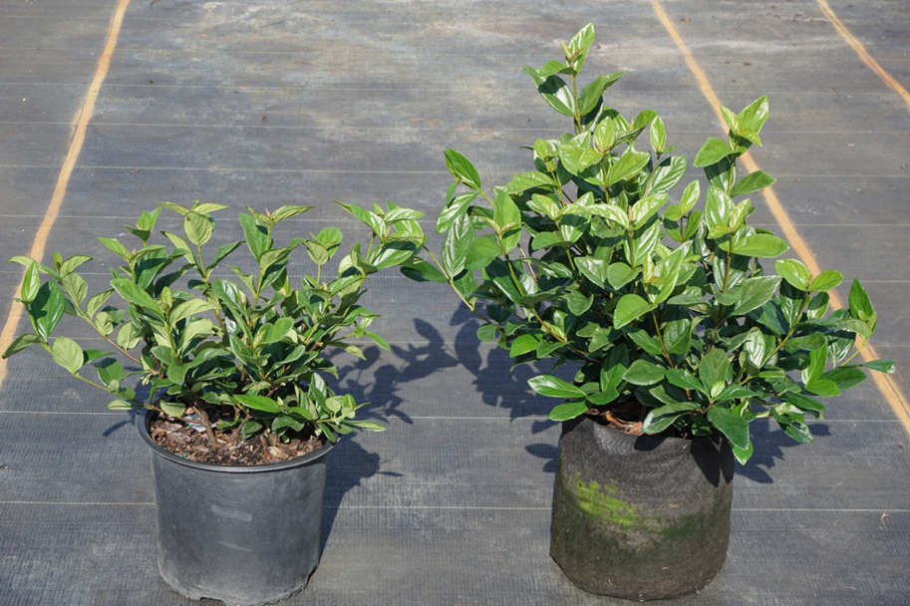

Fig. 1. *Viburnum suspensum* plants in Dec. 2021 after six months growth at Hibernia Nursery with trade 3-gallon conventional plastic container (left) or 3-gallon Smart Pot® (right).

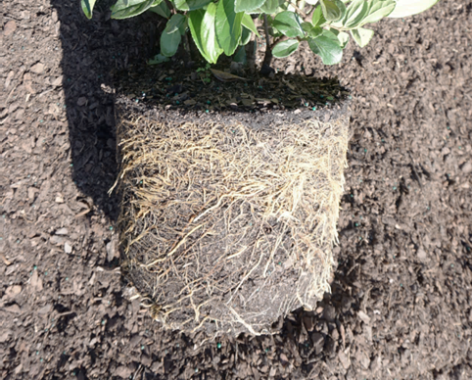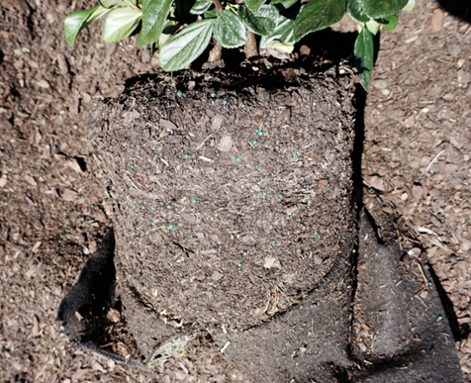

Fig. 2. Roots of *Viburnum suspensum* plants at time of transplanting (28 Dec. 2021) to trade 7-gallon containers. Plants shown are from trade 3-gallon conventional plastic container (left) or 3-gallon Smart Pot® (right).

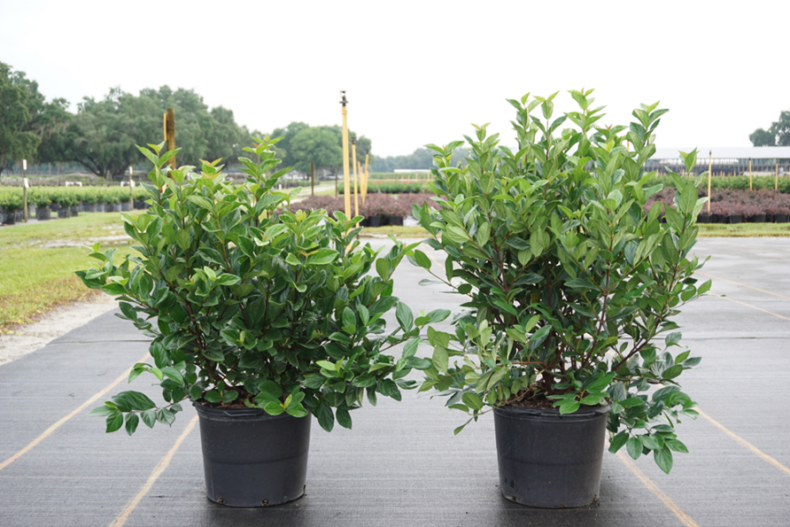

Fig. 3. *Viburnum suspensum* plants (May 2022) after transplanting to trade 7-gallon containers in Dec. 2021 from either trade 3-gallon conventional plastic container (left) or 3-gallon Smart Pot® (right).

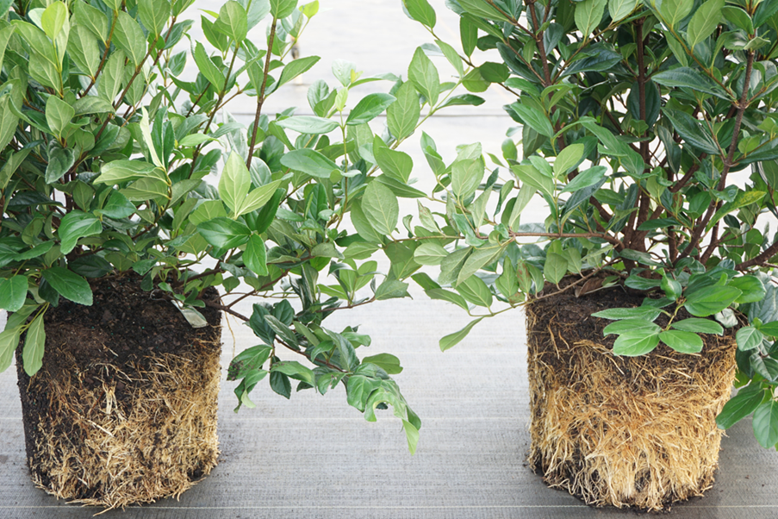

Fig. 4. Roots of *Viburnum suspensum* in May 2022 after transplanting to trade 7-gallon containers in Dec.2021 from either trade 3-gallon conventional plastic container (left) or 3-gallon Smart Pot® (right).